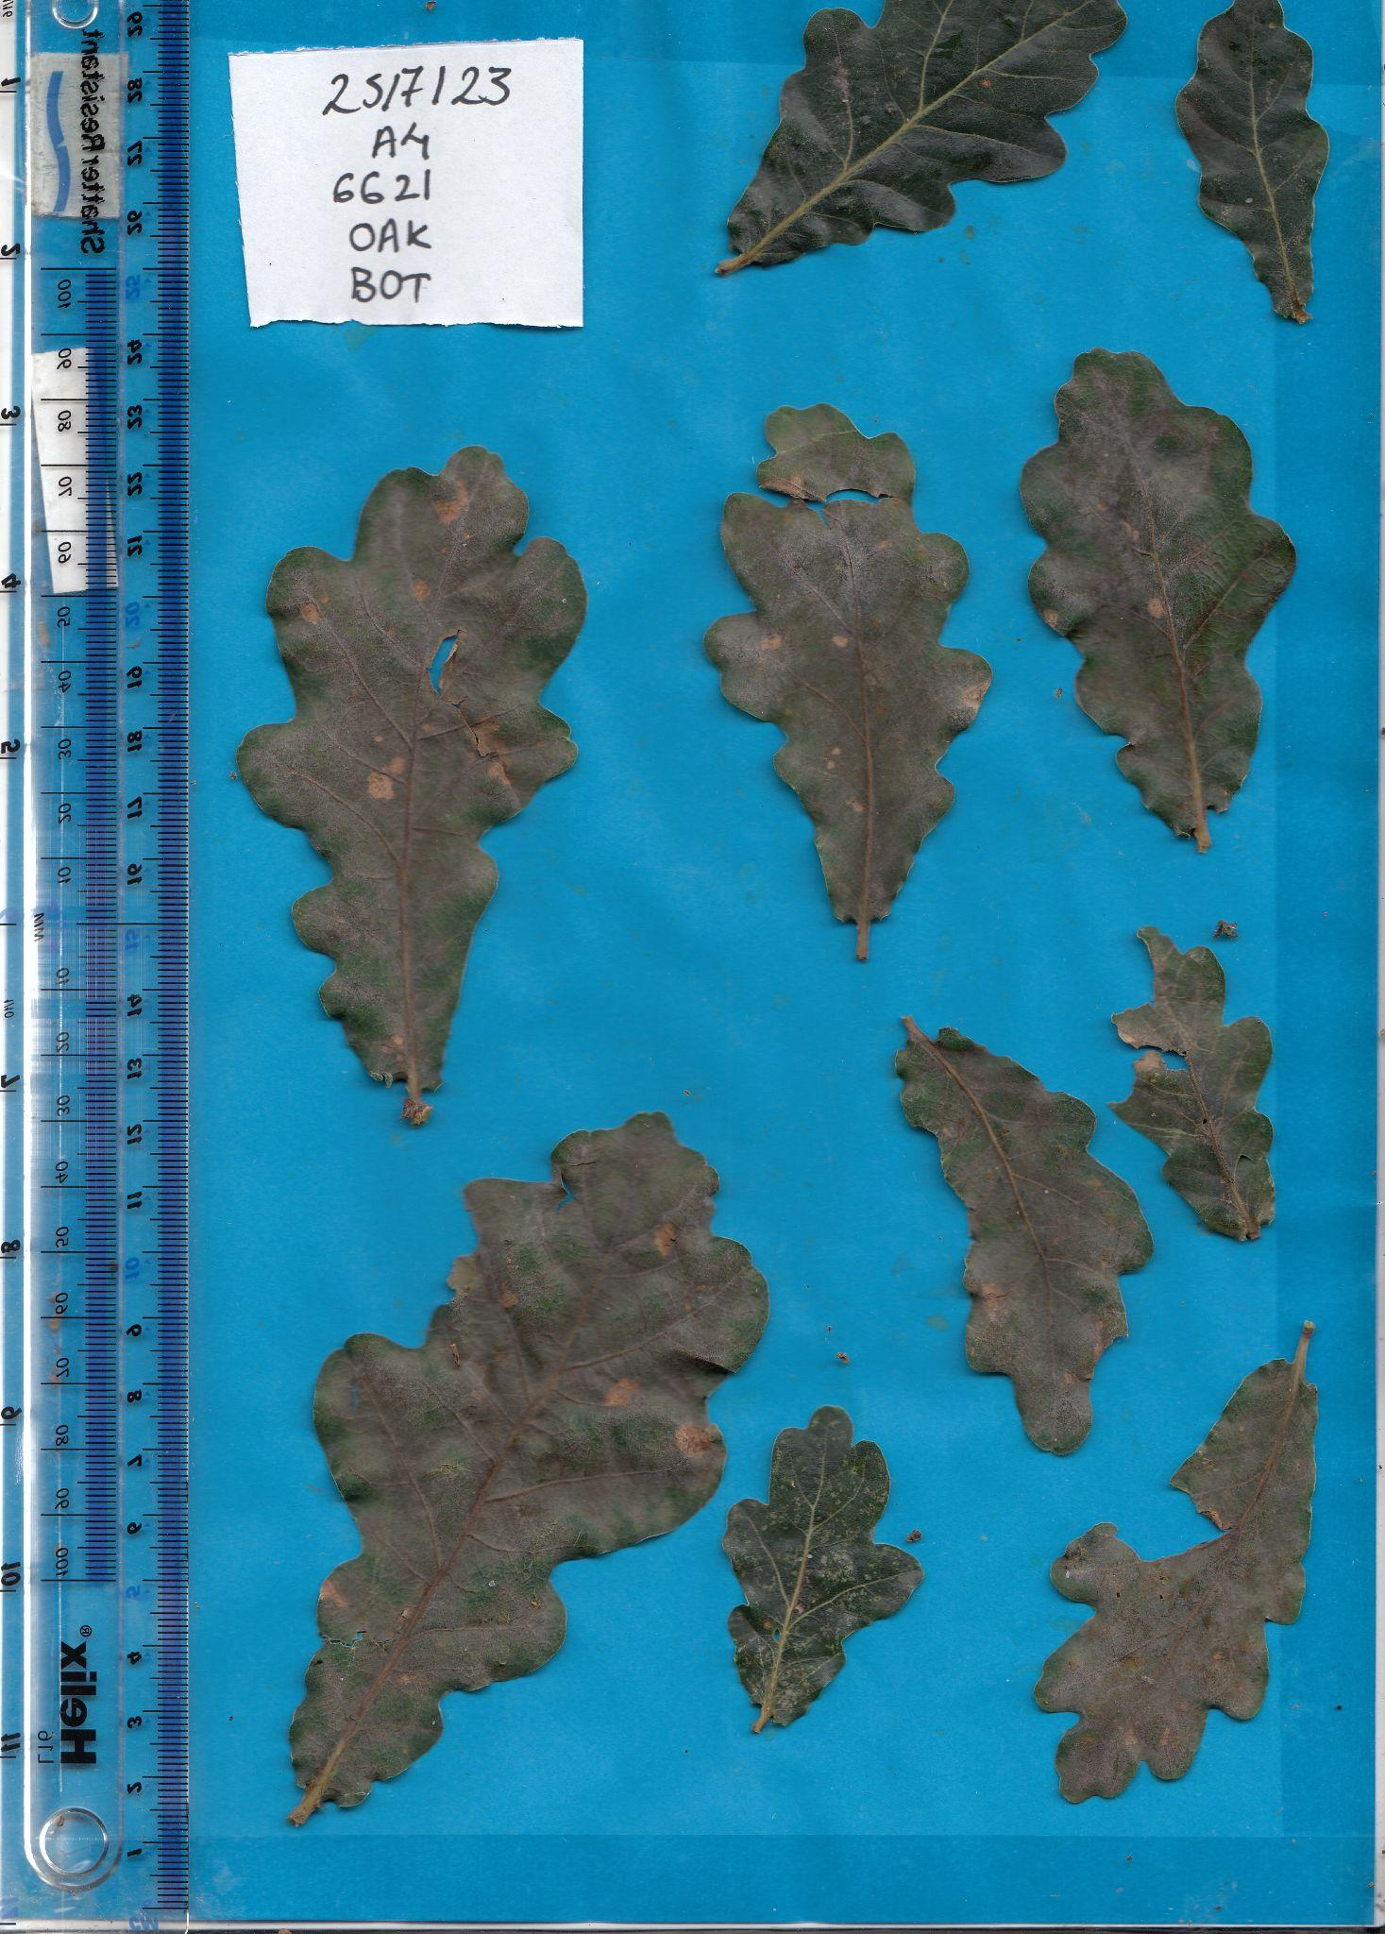

Example Image: Minorly Infected Oak Leaf with Powdery Mildew- PM % Score: 38.63723

